Sakhaa - MasterPiece Project Documentation

Developed by : Rahaf Alsmairat

# Table of Contents

1. Project Overview  
2. Technologies Used  
3. Project Features  
4. System Architecture  
5. Database Design  
6. Challenges Faced  
7. Future Enhancements  
8. Conclusion

# 1. Project Overview

Sakhaa is a donation-based web platform focused on providing food support to families in need. The system allows users to donate through various subscription plans, view and filter public donation reports, and access annual reports and success stories. It features a donation gifting option, corporate partnerships, beneficiary feedback, and an application form for families seeking assistance. Built with a user-friendly interface, Sakhaa aims to promote transparency, encourage community involvement, and simplify the donation process while ensuring support reaches those who need it most.

# 2. Technologies Used

## Front-End:

**HTML5:** Used to structure the content of web pages in a semantic and accessible way.

**CSS3+SASS:** Applied to style the interface with custom designs and enhance user experience.

**JavaScript:** Enabled dynamic content and interactivity throughout the platform.

**Bootstrap:** Provided a responsive, mobile-first layout and prebuilt UI components.

## Back-End:

**C#:** The primary programming language used for implementing business logic and server-side functionality.

**ASP.NET Core MVC:** A powerful, cross-platform web framework used to structure the application using the Model-View-Controller pattern, enabling clean separation of concerns, routing, and RESTful services.

**Entity Framework Core:** Used as the Object-Relational Mapper (ORM) to interact with the database in an efficient and maintainable way.

## Database:

**SQL**: Used for querying and managing relational data.

**SQL Server**: A reliable and scalable relational database management system used to store and manage all application data, including users, donations, reports, and more.

# 3. Project Features

Sakhaa project includes the following key features:

* User registration and login system
* Food donation platform
* Multi-level subscription system
* Donation log with history tracking
* Filterable and downloadable donation reports (e.g., by year)
* Annual reports page
* Success stories section
* News and announcements page
* Corporate sponsorships integration
* User feedback and beneficiary testimonials
* Contact form with message storage and email notification
* Donation gifting feature (send a donation as a gift)
* Online application form for families in need
* Responsive and accessible user interface
* Admin panel for managing users, reports, stories, and content
* User profile management with editable details
* Address and payment method customization (if added)

# 4. System Architecture

Sakhaa follows the **ASP.NET Core MVC** architecture, separating the application into three main layers:

* **Presentation Layer:** Built with Razor Views, HTML5, CSS3, JavaScript, and Bootstrap to create a responsive and user-friendly interface.
* **Application Layer:** Developed using ASP.NET Core MVC, it manages routing, controller logic, form handling, role-based access, and email services.
* **Data Layer:** Uses Entity Framework Core to interact with a SQL Server database, storing all user data, donations, reports, feedback, and more.

# 5. Database Schema

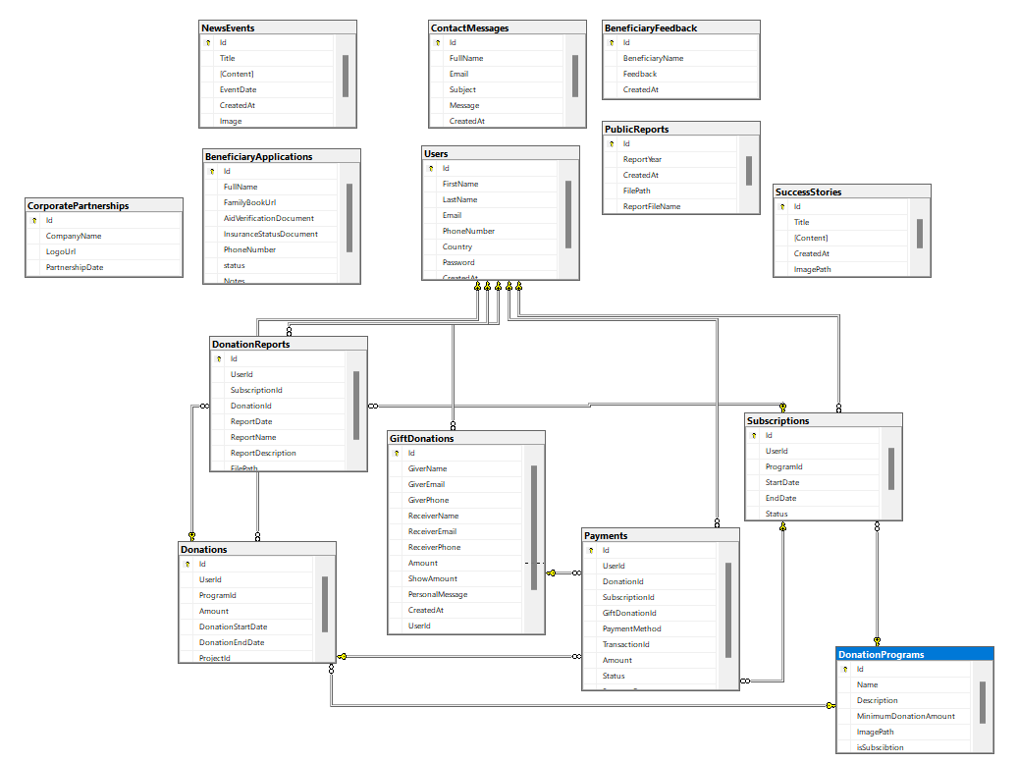

# 6. Challenges Faced

* **Role Management Complexity:** Implementing and securing multi-role access (admin, user) required careful planning and testing to ensure proper authorization and navigation flow.
* **Report Filtering & Exporting:** Developing dynamic report filtering by year and generating accurate downloadable PDFs demanded extra effort in logic handling and third-party library integration.

# 7. Future Enhancements

Planned future improvements to enhance the functionality and user experience of the Sakhaa platform:

* **Mobile App Integration:** Develop a mobile application version to increase accessibility and allow users to manage donations and reports on the go.
* **Online Payment Gateway:** Integrate a secure online payment system to enable direct monetary donations and streamline the support process.

# 8. Conclusion

In conclusion, the Sakhaa project successfully delivers a streamlined and user-friendly platform for managing food donations, addressing key community needs while providing a solid foundation for future growth and enhancements.